RIYA BIREN MEHTA (100716539)

Data tools and analytics

FINAL ASSIGNMENT

Analysis in this final project I made is Does frequency of mental health illness and attitudes towards mental health vary by geographic location or not? So, for accurate results, I have used python as programming language in order to receive the accurate results of our research and analysis. I created a python code and then through visualization we can evaluate the results of our purpose of research.

Firstly, we imported the libraries

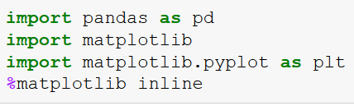

Loading the dataset:

After, Importing the libraries, we load the dataset and import the Survey file which was in csv format.

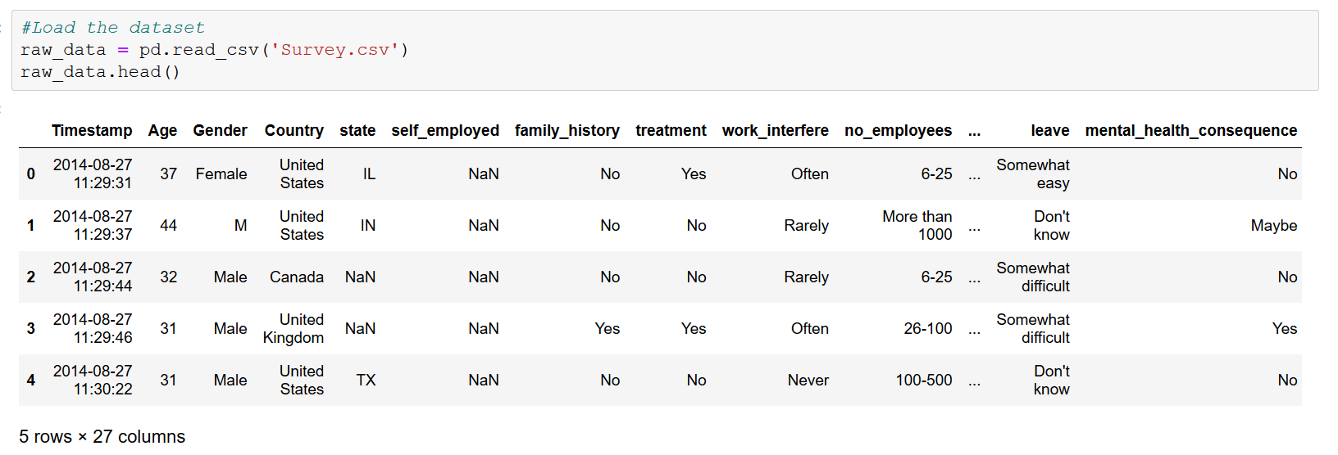

Analysis:

Here, we created data frames and did the analysis by choosing reliable variables we think are important as a factor to affect the mental illness in specific area. According to me, I think self employed is something that might be the cause of stress, anxiety and many disorders and can eventually affect mental health. Wellness program co-relates the mental health and hence it can be researched that how much people are actually aware and know and take benefit about wellness program. I have displayed the results of self-employed people in various countries so that we can get the accurate results.

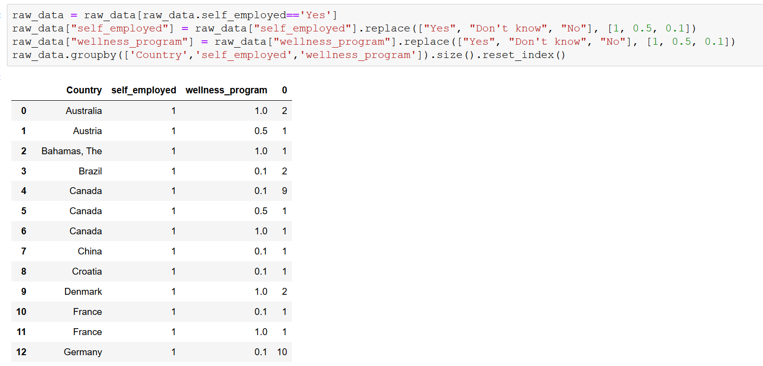

Visualization of country and wellness program:

We plotted the bar in order to visualize country and wellness program and we can see the co-relation and study and can evaluate the mental health effect. Wellness program and country has partial results as not all is YES and not majority is NO. There are people who use wellness program and there are people who don’t.

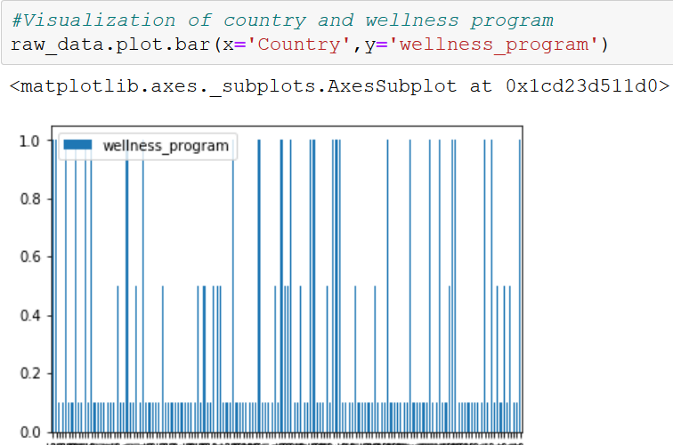

Visualization of self employed and wellness program:

We plotted the bar in order to self-employed and wellness program and we can see the co-relation and study and can evaluate the mental health effect. Wellness program and self employed is majority of positive response as we can see.

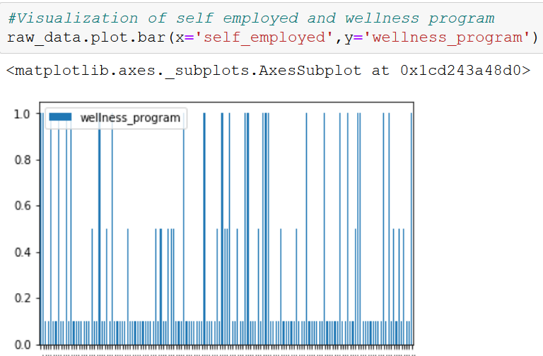

Visualization of self employed and country:

We plotted the bar in order to self-employed and country and we can see the co-relation and study and can evaluate the mental health effect. This combination has the most outstanding results as everything is in positive and there is no negative responses.

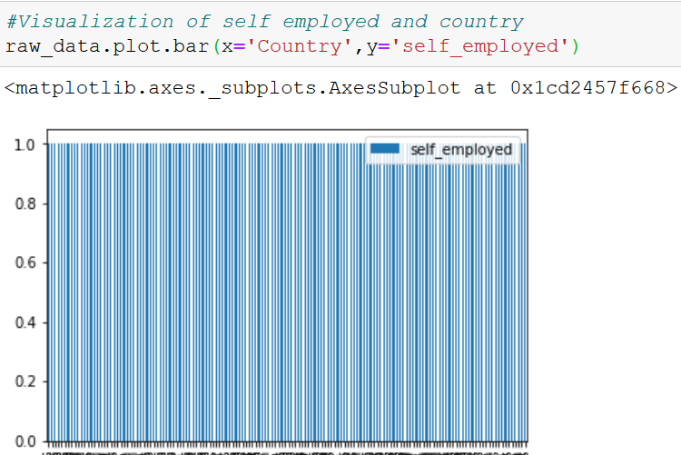

**CONCLUSION:**

There are people in this world who are self employed and they are having mental illness due to that and they don’t know about wellness program and they need to be educated regarding it.

The files which I have uploaded on GitHub are as below:

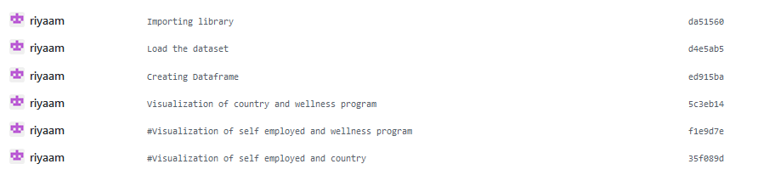

**Link for my GitHub Project:**

https://github.com/riyaam/Data-Final.git